**Personal profile**

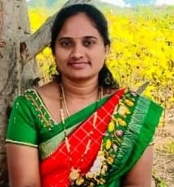 **1.FACULTY: CH. VASANTHA Department of Mathematics**

**Qualification: M SC [ Mathematics]; B.Ed.**

**TGTWRDC (G) ASIFABAD- 504293**

**Telangana State, India.**

**Email: chinthalavasantha13@gmail.com**

| **Father’s Name**  **Mobile** | **Bio Data**    **: CH. Narasaiah**  **: 9398009846** |
| --- | --- |
| **Mother’s Name Total Experience** | **:Eshwari**  **: 7 years** |
| **D.O.B**  **Date of Joining** | **: 19-09-1988**  **: 21-10-2019** |
| **Caste** | **: BC** |
| **Religion** | **: Hindu** |
| **Nationality** | **: Indian** |

**EDUCATIONAL QUALIFICATIONS**

* **Master of Science in Mathematics from Kakatiya university.**
* **Bachelor of Education from Kakatiya university.**
* **Bachelor of Science in Computer Science from Kakatiya University.**

**SERVICE PARTICULARS:**

| **Sl.**  **No** | **Designation** | **Name of the College** | **Working Period** | | **Length of Service** |
| --- | --- | --- | --- | --- | --- |
| **From** | **To** |
| **1** | **Junior Lecturer** | **TTWURJC Sirpur T** | **June 2018** | **October 2019** | **1 years** |
| **2** | **Guest Degree Lecturer** | **TGWRDC(G); Asifabad** | **21st** October **2019** | **Till** | **6 years** |

**Personal profile**

**2. FACULTY: K. SNEHA DEEPA** 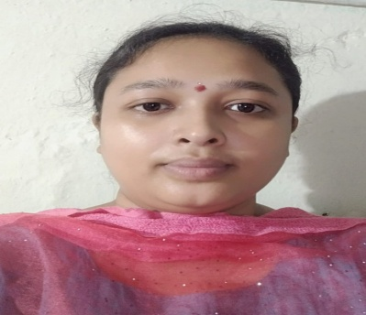

**Department of Mathematics**

**Qualification: M SC [ Mathematics]; B**.**Ed.**

**TGTWRDC(G) -ASIFABAD- 504293**

**Telangana State, India.**

**Email: ksnehadeepak@gmail.com**

| **Father’s Name**  **Mobile** | **Bio Data**    **: K. Ramesh**  **: 7287821992** |
| --- | --- |
| **Mother’s Name Total Experience** | **:Sumati**  **: 6 years** |
| **D.O.B**  **Date of Joining** | **: 26 -06-1993**  **: 22-03-2021** |
| **Caste** | **: BC-B** |
| **Religion** | **: Hindu** |
| **Nationality** | **: Indian** |

**EDUCATIONAL QUALIFICATIONS**

* **Master of Science in Mathematics from Osmania university.**
* **Bachelor of Education from Kakatiya university.**
* **Bachelor of Science in Computer Science from Kakatiya University.**

**SERVICE PARTICULARS:**

| **Sl.**  **No** | **Designation** | **Name of the College** | **Working Period** | | **Length of Service** |
| --- | --- | --- | --- | --- | --- |
| **From** | **To** |
| **1** | **Teacher** | **Vishwashanti high school** | **2017** | **2018** | **1years** |
| **2** | **Degree Lecturer** | **Vasundhara degree college** | **June 2018** | **May 2020** | **2years** |
| **23** | **Guest Degree Lecturer** | **TGWRDC(G); Asifabad** | **22 march 2021** | **Till** | **3 years** |